**INTI International College Penang School of Engineering and Technology**

**3+0 Bachelor of Science (Hons) in Computer Science, in collaboration with Coventry University, UK**

**3+0 Bachelor of Science (Hons) in Computing, in collaboration with Coventry University, UK**

**Coursework cover sheet**

**Section A - To be completed by the student**

|  |  |
| --- | --- |
| Full Name: Lim Ni Feih | |
| CU Student ID Number: 12672774 | |
| Semester:2 | |
| Session:  **April 2022** | |
| Lecturer:  **Nadhrah Abdul Hadi (nadhrah.abdulhadi@newinti.edu.my)** | |
| Module Code and Title:  **4067CEM Software Design** | |
| Assignment No. / Title:  **Continuous Assessment** | % of Module Mark:  **50** |
| Hand out Date:  **22nd April 2022** | Due Date:  **Task 1: 13 May 2022, by 11.59pm**  **Task 2: 1 July 2022, by 11.59pm**  **Task 3: 17 June 2022, by 11.59pm.**  **Task 4: 17 June 2022, by 11.59pm.**  **Task 5: 17 June 2022, by 11.59pm.** |
| Penalties: No late work will be accepted. If you are unable to submit coursework on time due to extenuating circumstances, you may be eligible for an extension. Please consult the lecturer. | |
| Declaration: I/we the undersigned confirm that I/we have read and agree to abide by the University regulations on plagiarism and cheating and Faculty coursework policies and procedures. I/we confirm that this piece of work is my/our own. I/we consent to appropriate storage of our work for plagiarism checking.  Signature(s): ____________LNF____________ | |

**Section B - To be completed by the module leader**

|  |  |  |
| --- | --- | --- |
| Intended learning outcomes assessed by this work:  1. Understand and apply appropriate concepts, tools and techniques to each stage of the software development  2. Understand and apply design patterns to software components in developing new software  3. Demonstrate an understanding of project planning and working to agreed deadlines, along with professional, interpersonal skills and effective communication required for software production  5. Demonstrate an awareness of, and ability to apply, social, professional, legal and ethical standards as documented in relevant laws and professional codes of conduct such as that of the Malaysian National Computer Confederation. | | |
| Marking scheme | Max | Mark |
| 1. User Story Mapping 2. Setting up a GitHub Repository 3. Creating a Class diagram and design pattern selection 4. Creating a Prototype User Interface and Usability Testing 5. Discuss the ethical issue related to the software | 20  10  30  20  20 |  |
| Total | 100 |  |

# 1 Cyber Laws

## 1.1 International Data Privacy Principles

The IDPP’s approach takes into consideration the Asian, European, US and international data protection standards and focuses on personal data, but can apply to corporate data as well. These principles suggest that the three parameters (payment, consent and data category) should be balanced and combined with the previously mentioned, Asian, European, US, and international standards, putting them into a set of privacy rules. Organizations in compliance with international data privacy standards should commit to the 13 IDPP.

#### Implementation of IDPP into Software

Complying with the first principle stated in IDPP, the software complies with Personal Data Protection Act (PDPA) which is a data protection law enforced in Malaysia.

According to the second principle, the personal data of users are to be protected from unauthorized access. With that in mind, the software requires the user to input their email and password to avoid unauthorized access to their account.

To implement the third principle, the users can view the terms and conditions and privacy statement of using the application via the sign-in page. The terms and conditions and privacy statements include contents protected by international copyright law, warranty disclaimer that limits the software owner’s liability, guidelines for using the application, the person in charge of the data privacy, how the data will be used, the person receiving the data, duration of data stored, and the data that will be deleted, or rectified upon request. It is also stated that by signing into the application, they agree to the conditions.

By complying with the sixth and seventh laws mentioned in IDPP, the data that are to be input into the application are necessary for an excellent user experience and carrying out the functions of the application. For example, the user has to input the name, course of study, and phone number to register for an event in the application for the organizer’s use. Besides, the user can allow the application to access the location of the user for him/her to know what events are happing nearby. Not only that, the user can also input their bio, and name so that other users can know him/her more. This data can act as a catalyst for the users to know each other better.

#### Effects on society if IDPP is violated within the Software

If the first principle of IDPP is to be violated, any person who has control or authorizes the processing of any personal data in respect to commercial transactions will be charged criminal offense.

If the second principle is violated, a data breach will occur and unauthorized users will be able to access the personal data of users. This can cause the loss of trust of users towards the software. Not only that, leakage of sensitive information of users could also be used against them as threat.

If the third principle of IDPP is violated, the users can abuse the application, violate the guidelines for using the application, steal the logo and contents of the application which are protected by the Copyright Act 1997, and abuse the power of holding the owner of software responsible for any error in the content presented in the application.

If the sixth or seventh law is violated, data saturation can occur which leads to redundancy. Besides, the data gathered that are unnecessary or excessive can lead to misdirection for analysis, loss of trust of users, difficulty in prioritization for users’ experience and higher costs of storage, quality assurance, and security.

## 1.2 Privacy Data Protection Act 2010

PDPA was enforced in Malaysia on 15th November 2013. This Act applies to any person who processes; and any person who has control over or authorizes the processing of, any personal data in respect of commercial transactions. All individuals and organizations that process personal data in their dealings must comply with the rules set out in the Personal Data Protection Act 2010. The Federal Government and the State are exempted from obliging by this Act. An organization must comply with the Act only if the organization is "processing" personal data. "Processing" personal data means doing something towards the data including **collecting, recording, holding, storing, organizing, modifying, disclosing and destroying.** Examples of activities that can be considered as "processing" include **collecting data through forms, by phone or via the web, publishing data, selling data, using administrative data, using data for marketing purposes, recording data, disclosing or providing data to other organizations, and destroying data.**

**Scope of the PDPA:**

This law was passed to provide protection for an individual's personal information to be processed for the purposes of commercial transactions.

The PDPA asserts seven principles that have to be complied with when processing personal data. Certain Principles are qualified for exceptions and exemptions.

The principles of PDPA are as the following:

1. General Principle

The General Principle prohibits a data user from processing an individual's personal data without their consent. Consent must be "recorded" and "maintained" which means that consent is required.

The PDPA only allows procession for a lawful purpose directly related to the activity of the data user. The data processing is to not be excessive in relation to that purpose.

Explicit consent is required for the processing of "sensitive personal data". This includes data about health, political opinion, religious beliefs, and commission or alleged commission of an offense.

1. Notice and Choice Principle

A data user needs inform an individual by written notice in English and the national language that his personal data is being processed by or on behalf of the data user, the purposes of collecting the personal data and further processed, the rights of the individual to request access or correction of the personal data, methods on how to contact the data user if he has any inquiries or complaints regarding the personal data, class of third parties that has access to the personal, the choice to limit the processing, whether obligatory or voluntary for the individual to supply the personal data and the consequences if he fails to supply.

### Disclosure Principle

The data user shall not disclose a data subject’s personal data, unless it is for the purpose for which it was originally collected without the consent of the individual.

### Security Principle

The data user shall take practical steps to make sure the personal data does not suffer from any loss, misuse, modification, unauthorized or accidental disclosure, alteration or destruction.

### Retention Principle

Under this principle, the personal data processed shall not be kept longer than is necessary for the fulfillment of that purpose.

### Data Integrity Principle

The data user has to take responsible steps to ensure that the personal data is accurate, kept up-to-date, complete, and not misleading ,

### Access Principle

An individual needs to be given access to his personal data held by a data user and be able to correct it at any time.

### How to comply with PDPA

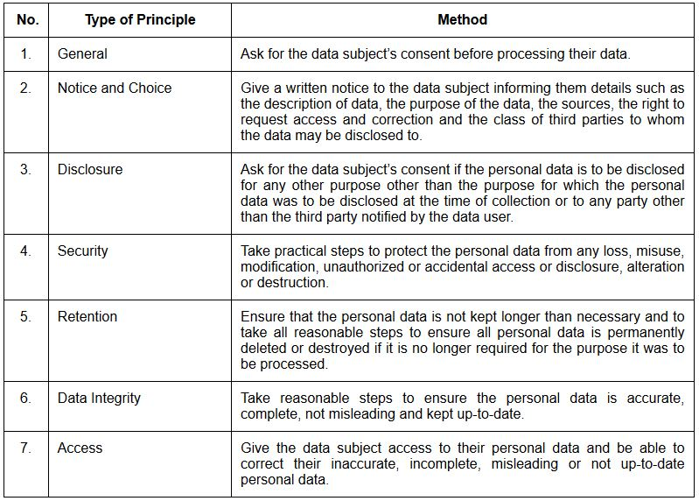

#### Implementation of PDPA into the Software

According to the General Principle, Notice and Choice Principle, and Disclosure Principle, a few steps have been taken such as the terms and conditions and privacy policy has been written. The individual can view the contents on the sign-in page. The contents of the terms and conditions and privacy policy cover the rules of using the application, the fact that the personal data input into the system by the individual is being used, the description of the data, the purposes for which the personal data is being collected and further processed, any information available to the data user as to the source of that personal data, the individual's right to request access to and correction of the personal data and contact particulars of the data user in the event of any inquiries or complaints, the class of third parties to whom the data is or may be disclosed, the choices and means offered to the individual to limit the processing of the data and whether it is obligatory or voluntary for the individual to supply data, and if obligatory, the consequences of not doing so. The individual gives consent to the processing of personal data according to the terms set when the individual signs into the application. Not only that, when the application has to access the individual’s device such as accessing the location of the individual, sending notifications to the individual’s device, and more, the application will pop up overlays to confirm whether the individual allows the application to do so or not and will not be permitted to carry out the function if denied access by the individual.

For the Disclosure Principle, the individual’s personal data will only be accessible by the data users who are stated in the terms and conditions and privacy policy of using the application.

For the Security Principle, the individuals have to sign in to the application with the individuals’ student email and password to have access to their accounts. Unauthorized individuals cannot access the account with this implementation. Not only that, if someone tries to reset the password of another’s account, the application requests for the 6 digit code that will only be sent to the individual’s student email before it allows the person to reset the password.

For the Retention Principle, the personal data of the users of the application will not be kept and will be deleted permanently if no longer needed by the system.

To ensure the application system abides by the Data Integrity Principe and Access Principle, the application allows the user to edit the personal data such as the profile picture, bio, email and personal information on the application through the settings page.

#### Effects on Society if PDPA is violated within the Software

Non-compliance by a data user with any of the principles constitutes an offense under the PDPA. The penalty includes fines and/or imprisonment.

If the data user does not abide to PDPA, data breach will easily occur as there is no protection of the personal data of the users of the system against unauthorized user. This will lose the trust of the user of the system and cause people to not use the application anymore. Not only that, the information of the users of the application will be inaccurate which can lead to misunderstanding and cause frustration to them. Besides, users of the application will also not use the application if it does not respect their privacy due to accessing and processing their per

## 1.4 Copyright Act 1997

The law on copyright in Malaysia is governed by the Copyright Act 1987 which was enforced on 1st December 1987.

The kinds of works that are protected under the copyright law include (a) literary works, such as books, pamphlets, articles, letters, reports, compilations, and computer programs,(b) artistic works such as paintings, drawings, diagrams, photographs, sculptures, works of architecture, works of artistic craftsmanship, (c) musical works, (d) films, (e) sound recordings, and (f) broadcasts.

The owner of the copyright is given the exclusive right to do some specified restricted acts relative to the work. The first owner of a copyright is the author of the work. However, if the employee made the work, then the employer will be the first owner of the copyright unless otherwise agreed.

The following acts are restricted by the copyright and only the owner can do so or give authorization to others to do so:

1. Copy the work
2. Issue copies of the work to the public
3. Rent or lend the work to the public
4. Perform, play, or show the work in public (for films, or shows)
5. Make an adaptation of the work
6. Do any of the above relative to an adaptation

Copyright Law: Digital Media

Web publication or any internet-based publication is considered to be inside the realm of copyright law. Anyone who wants to publish the work of others still needs the permission of the work’s owner.

#### Implementation of Copyright Act 1997 into the Software

According to the Copyright Act 1997, the users are not to copy the works of others such as using the image of the events for their own event or posting it on other platforms without the owner’s permission. It will be stated in the terms and conditions of using the application about the copyright acts and the users are not to take any image, video or work of others without the consent of the owner.

#### Effects on Society if Copyright Act 1997 is violated within the Software

If anyone who uses the application is proved to have commit copyright infringement, the offender can be sued which can lead to criminal penalties such as imprisonment up to 5 years.

# Computer Professionalism

Any person involved in information and communication systems in any way hold special responsibilities. They are considered computer professional and have to abide by certain standards and principles of conduct which is set by the Malaysian National Computer Confederation (MNCC), an association for information and communication technology professionals in Malaysia.

The five principles of MNCC are as follows:

## Integrity

The computer professional has to perform duties according to the existing laws and exercise high moral principles, and behave all times with integrity. One should provide guidance or advice based on experience and without discrimination.

## Confidentiality

The computer professional has to act in complete discretion when entrusted with confidential information and carry out his duty with diligence. Confidential information relating to affairs of his employers shall not be disclosed, permitted disclosure or used to own advantage without the employer’s permission.

## Impartiality

He has to always be fair and bias when performing all duties and provide impartial analysis and advice without any prejudice. When opinion is provided, he has to take it as an opinion instead of facts.

## Responsibility

The computing professional shall accept fill responsibility for any work that is done and deliver the tasks given with due diligence. He should know what responsibilities he has and complete his work on time. The employer should be alerted in advance if he cannot deliver any of his promises. He should also be considerate of the impact of the computer based systems towards the customers, suppliers, and general public based on basic human rights.

## Relationship to MNCC

He will not seek personal advantage to the detriment of the MNCC. He shall always abide to the principles of MNCC and not serve to his own advantage. He should conduct himself with coustesy at all times and apply high standard of behaviour.

I, as the developer of the application will abide by all the ethics and principles of MNCC stated above when developing the software.

#### Effects on the society if the computer professional does not abide to MNCC principle and ethics within the software

If the principles of MNCC are not abided, the user’s well-being will not be taken care of and data leakage can occur from not following the confidentiality principle and relationship to MNCC. Not only that, the developer and employer will get into lawsuit if integrity is not followed by the developer.